PROGRAM 1
1. DFA for strings that start with 'a' and end with 'a'
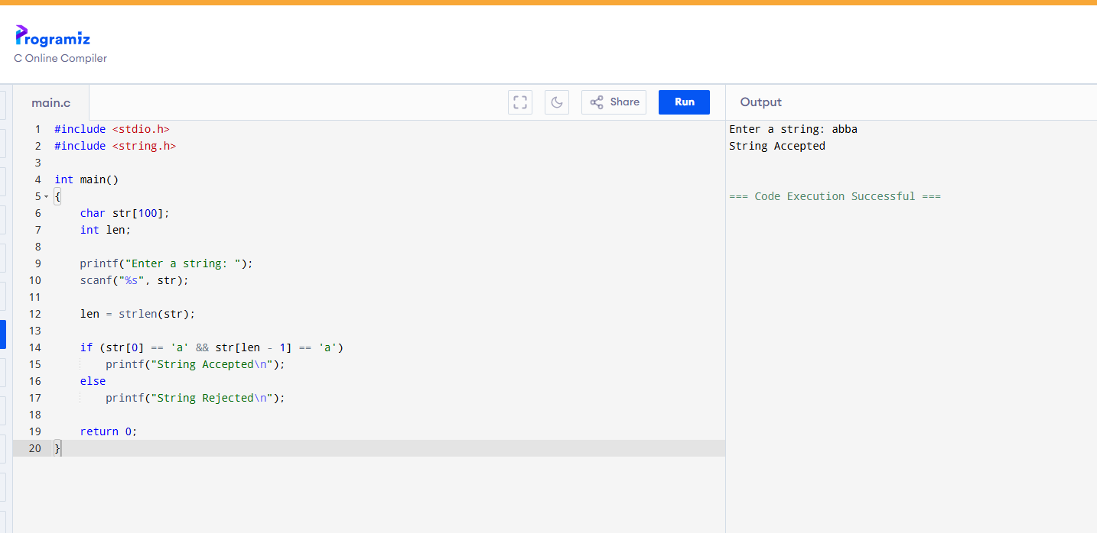

PROGRAM 2
DFA for strings that start with 0 and end with 1
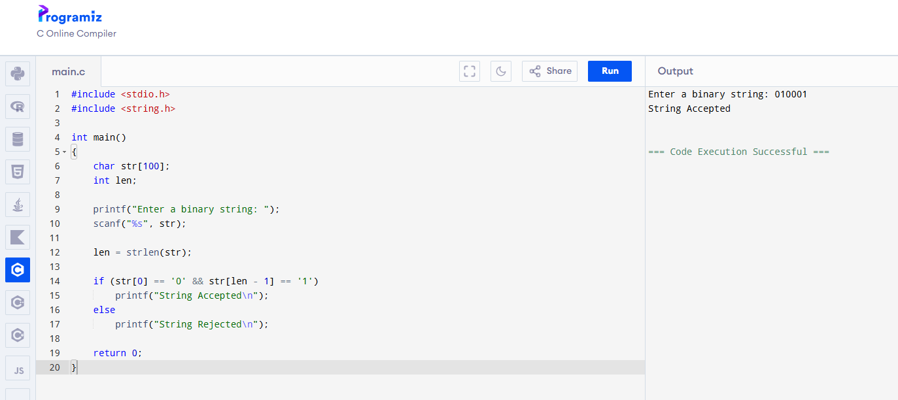

PROGRAM 3
CFG: S → 0A1, A → 0A | 1A | ε
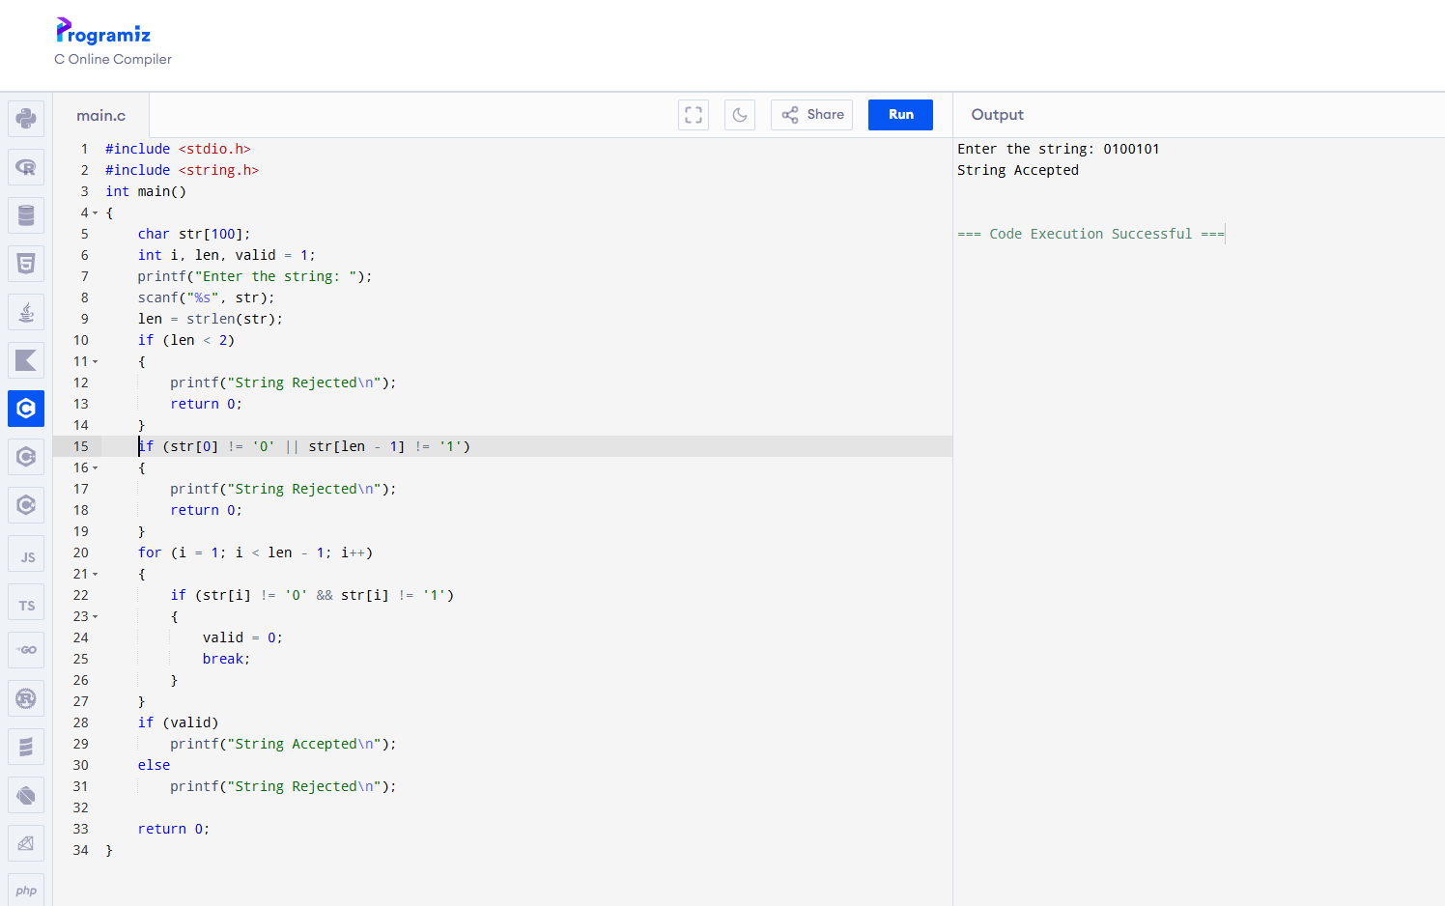

PROGRAM 4
CFG: S → 0S0 | 1S1 | 0 | 1 | ε (Accepts palindromes over {0,1})
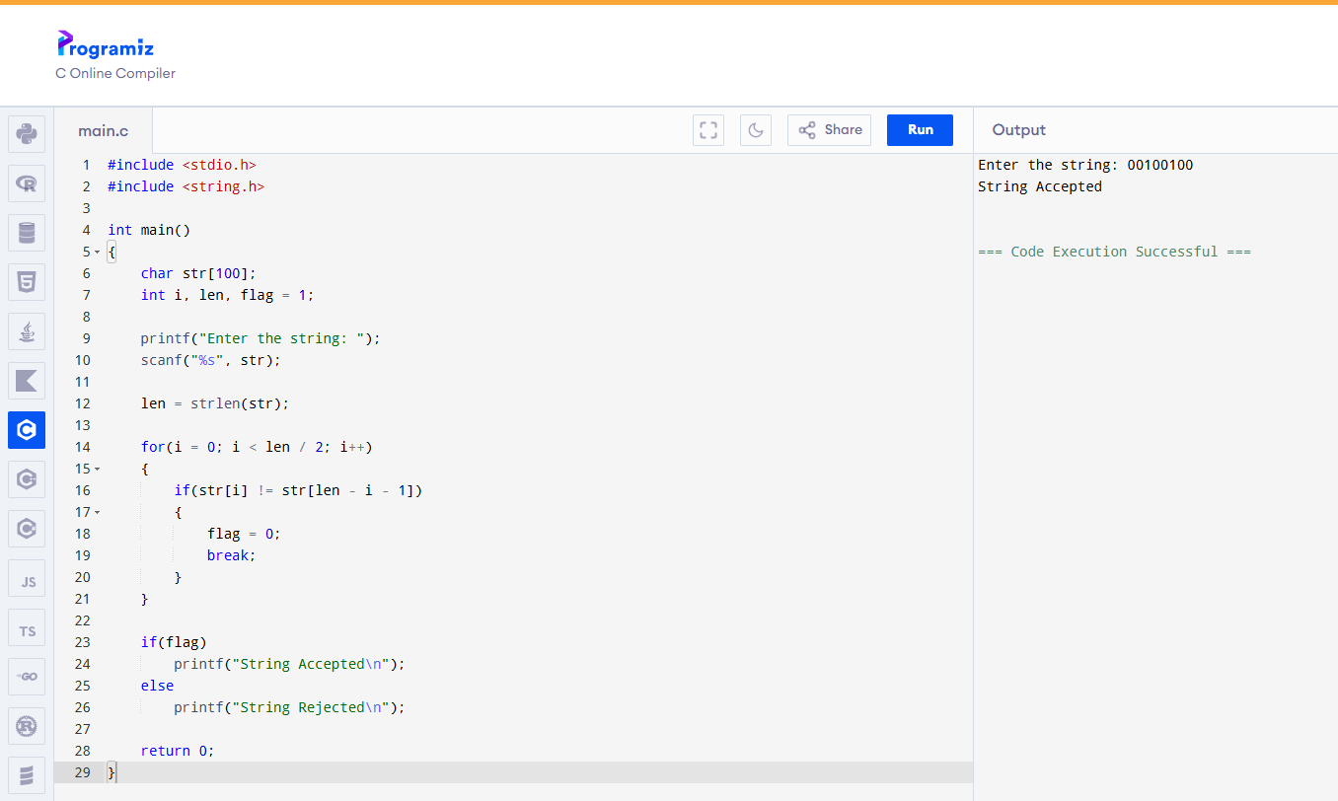
PROGRAM 5
CFG: S → 0S0 | A ,A → 1A | ε (Accepts strings of the form 0ⁿ1ᵐ0ⁿ)
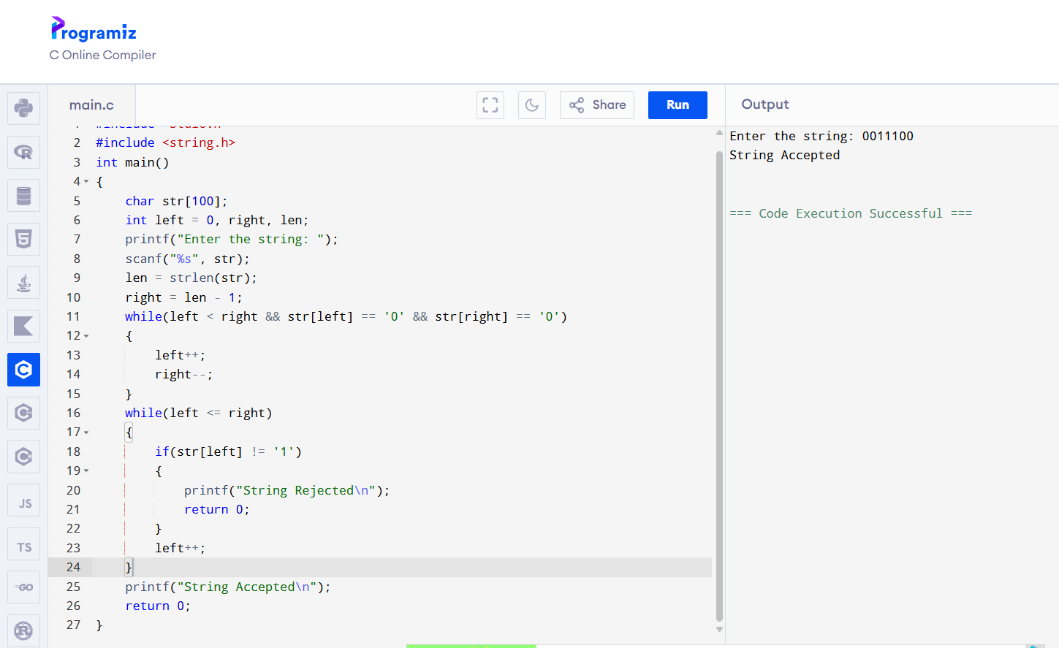

PROGRAM 6
CFG: S → 0S1 | ε (Accepts strings of the form 0ⁿ1ⁿ)
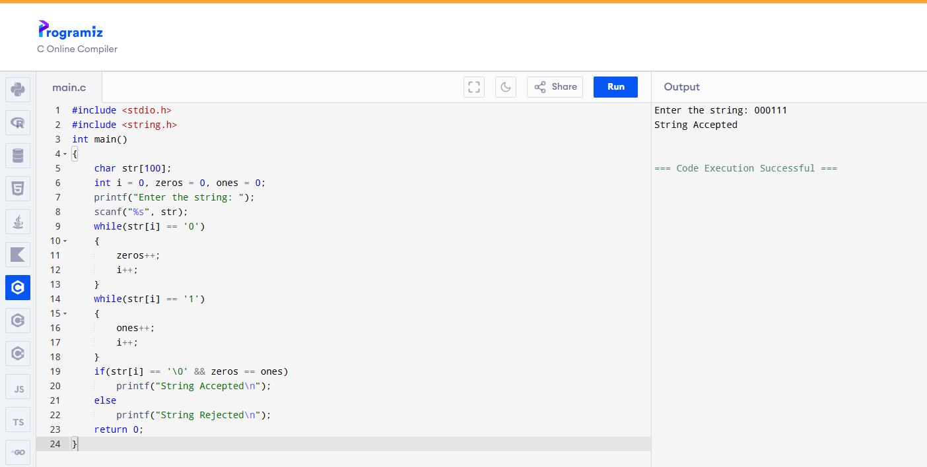

PROGRAM 7
CFG: S → A101A A → 0A | 1A | ε (Accepts all binary strings substring 101.)
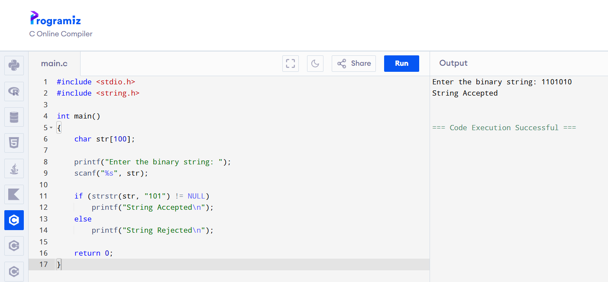

PROGRAM 8
NFA for strings that start with 'b' and end with 'a'
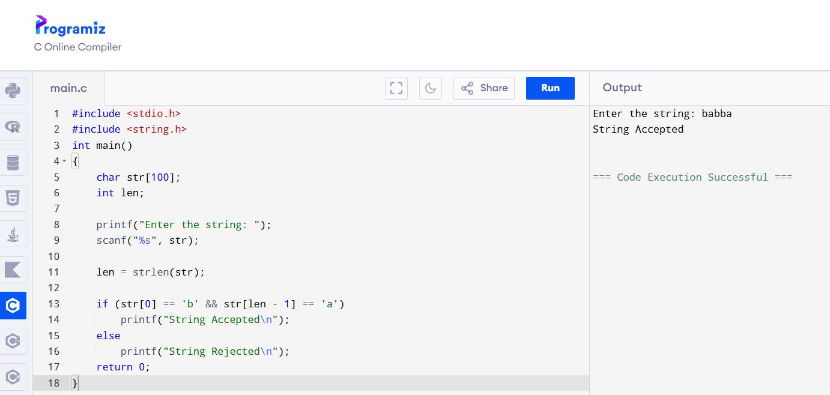

PROGRAM 9
NFA for strings that start with '0' and end with '1'
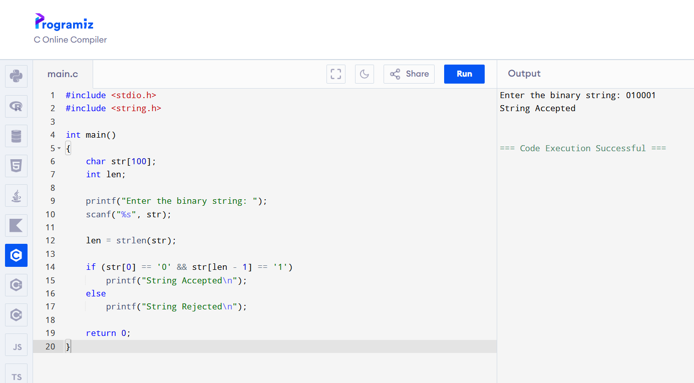

PROGRAM 10
Find ε-Closure for all states in an NFA with ε-moves
